38.67: a) The 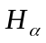 line is emitted by an electron in the 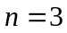 energy level, 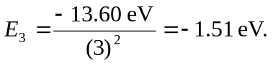 The ground state energy is 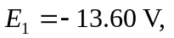 so one must add at least 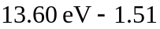 eV=12.09 eV if the line is to be emitted.
b) The possible emitted photons are 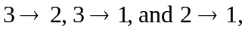 with the wavelengths given by 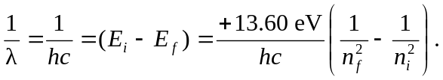 This yields the wavelengths of 658 nm, 103 nm, and 122 nm for the respective photons above.

